RCJA 2021 OnStage Technical Description Paper
Team Information
Division: Novice
Team Name: The Dreamteam
School: Brisbane Boys College
State/Territory: Queensland
Team Member Names:
If any team member had a specific role, please include this below.
Member 1: Sam Garg

Member 2: Matthew Adams

Member 3: Christopher Ashley

Member 4:

Member 5:

Collaboration
It is the overall desire of RoboCup Junior events that any technological and curricular developments will be shared with other participants after the event. Any developments including new technology and software examples, may be published on the RoboCup Junior website after the event, furthering the mission of RoboCup Junior as an educational initiative.
Scoring  Added to the Technical Interview Score | /10 | Novice | Experienced
Demonstrates that the work on display is authentic |  | /6 | /4
Hardware development process clearly indicated |  | /1 | /2
Performance concept development process clearly indicated |  | /1 | /2
Software development process clearly indicated |  | /2 | /2

Summary
What is the theme/performance/idea of The Performance? What is the main highlight in your Performance? What sensors should the audience look out for?
The performance/idea of the performance is that it revolves around The Chicken Dance. The main highlight of the performance is that it moves around with the music. A sensor that the audience should look for is the Compass.

Robot(s) Overview
Please include number and type all robots you have used in The Performance, including programming language(s).
We are using 2 robots that are EV3, we are currently using Lego Mindstorms Education EV3 Classroom Software for coding.

Mechanical Innovation
What was done to enhance difficult movements of the robots, such as moving smoothly, keeping balance, communication, avoiding objects, grasping objects, and so on.
Many things like A compass were useful for getting angles perfect, we also had to make wheels in special ways so that the robot was balances, to make the robot not crash into objects we used the strategy of ‘guess and check’.

We made it by basing it of a picture that I found on the internet and following the structure of the legs and modifying the rest.

Sensors
Which sensors are you using (for example Touch, Light, Sound, Rotation, Compass, Proximity, Ultrasonic, Colour)?
We are using the Compass sensor and light sensor.

Wireless Communication
Are you using wireless communication(s)? If so what type (for example Infrared (IR), Bluetooth (BLE or Classic))?
N/A

Programming Language
What programming language(s) are you using?
We are using EV3 Classroom block coding as our programming language.

The Highlight

The point what you want the audience and judges to show, usually the most important scene of The Performance.
When the robot goes around the tree in a ‘square’ shape.

Robot-Robot Interaction:

Is there any robot-robot interaction in your performance? How do the robots move?
N/A

Challenges and Difficulties:

What did your team find especially challenging? Did you overcome this? If so, how?
We found that coding the compass was very difficult to get the angles perfect, we spent about 20 hours working on the compass altogether. Instead, we added a range to solve this problem. One other challenge was building the legs of the robot because pieces were missing, so we improvised.

Photos and Images of the Robot(s)
If there is a design drawing of the robot or if you have photos or notes of the development process, please provide these as proof of your team’s learning.
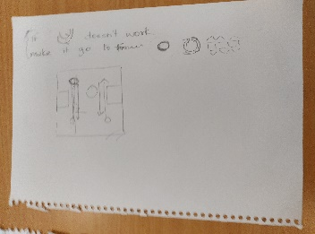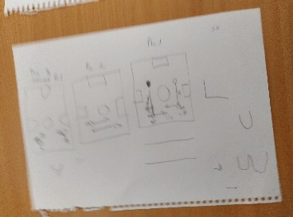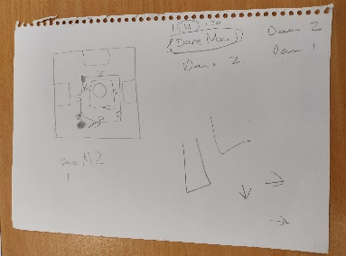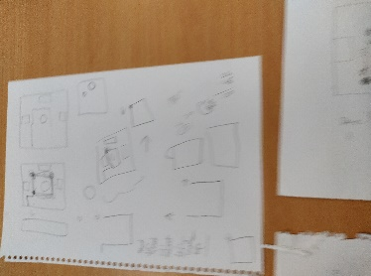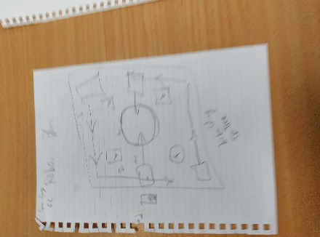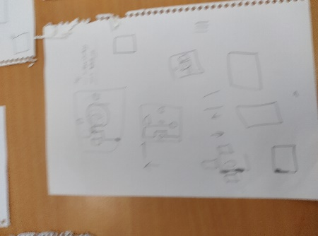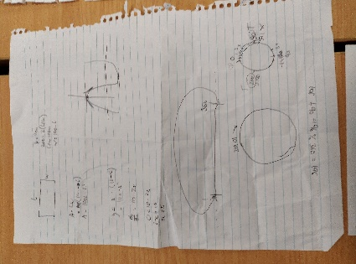
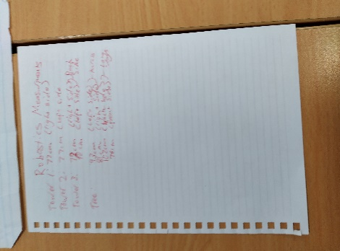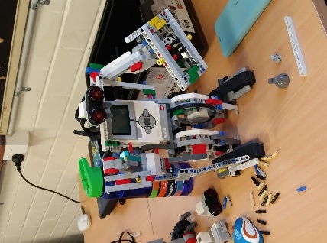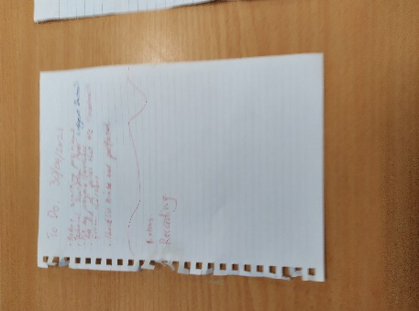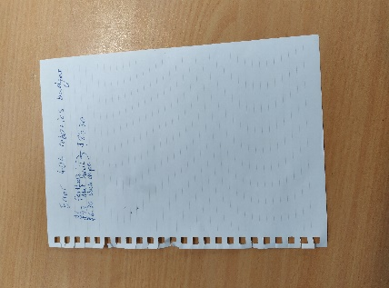
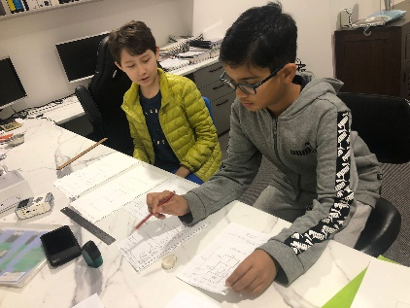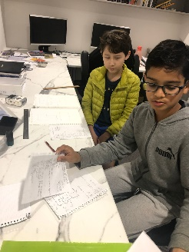

Your Learning Journey
Briefly list your learning journey/activities you went through towards building The Performance. This can be done in a chronological order (dates worked on) or in any way that best explains your performance development.
Term 3 (10 weeks)- We came Monday, Tuesday, Wednesday and Thursday every week for term 3, which were all 1 and a half hours, each session.
We came to holiday workshop which were on 20&21/09/2021, adding to this we also came to the 30/09/2021 and 1/10/2021 workshops.
Because we were doing a different project in Term 1 & 2, we will not include it in this document, but we completed the robots in the early stages of term one, this included 5 Mondays that consisted of 1 and a half hours each.

Extra Information
Is there anything else you would like to add?
N/A

